**Purpose:** This document contains the pre-requisite details while dealing with AWS resources via python

**Boto3** is the Amazon Web Services (AWS) Software Development Kit (SDK) for Python, which allows Python developers to write software that makes use of services like Amazon S3 and Amazon EC2.

How to Install Boto3

Open command prompt and issue below command

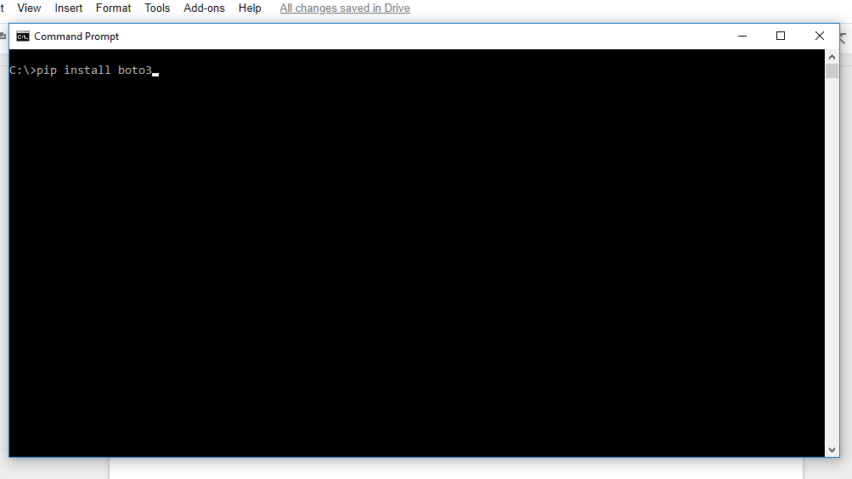

If “pip” is not installed on your machine you will get below error

***“Python-pip is not recognized as an internal or external command”***

**How to install pip**

Hit below url in the browser

<https://pip.pypa.io/en/stable/installing/#>

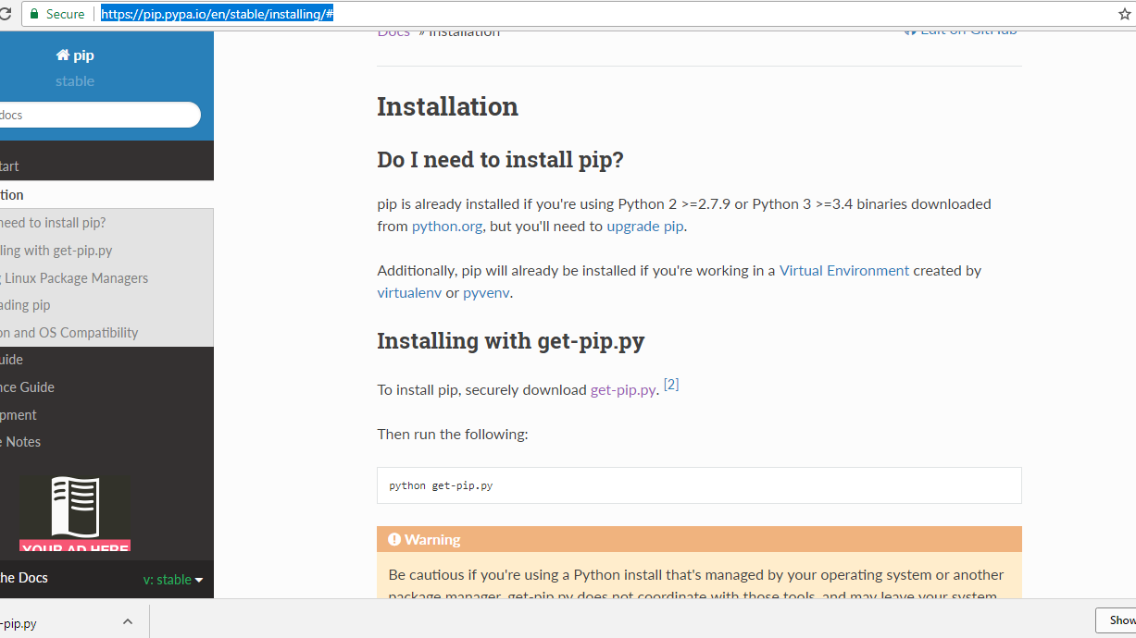

Search for **get-pip.py**

* Open this file in another tab.
* Copy the content and save on local computer as .py file.
* Now run this file. “Pip” will get installed on your computer.

Now check pip path. It should have been installed under Scripts folder inside python

Now set this path as environment variable.

Once it is installed properly type pip at the command prompt and you should get the screen as below

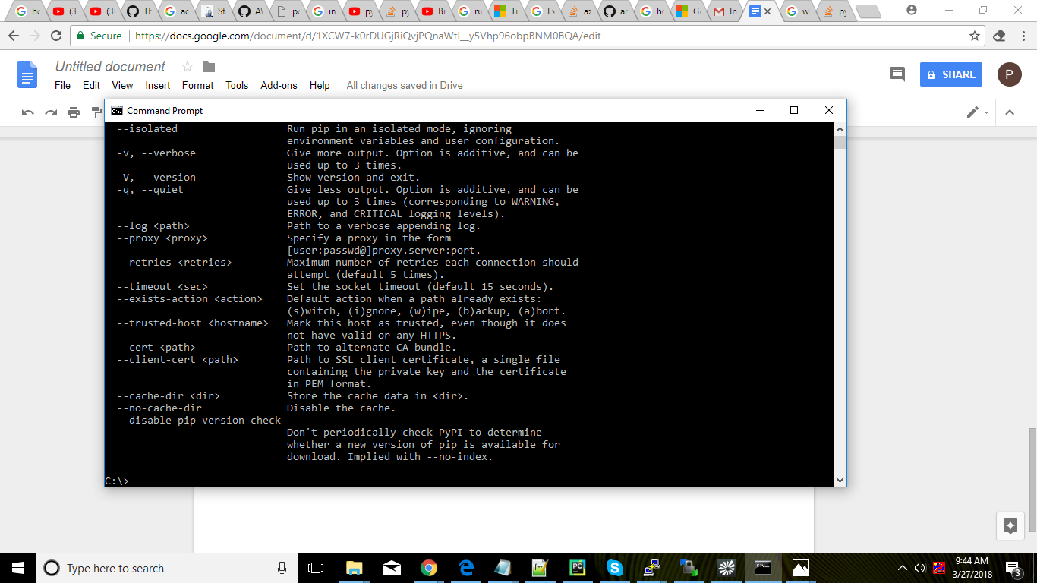

Now you are all set to fire above command at command prompt to install boto3. Goto command prompt and issue that command again

>>pip install boto3

To make config settings to deal with AWS resources we need to install AWSCLI

At command prompt issue below command

>>pip install awscli

Now we have to set environment variables for Secret key and access key in order to connect to S3 bucket

Issue below command at the command prompt and set the required variables.

>>aws configure

